**Exercise- Data Visualization using Gephi**

**Student Name: Pulkit Agrawal Student Id: PXA180017**

**Date: 11-09-2018**

**Question:**

1. **Paste the screen shot of your edges file after adding the 2 records as highlighted above.**

**Answer:**

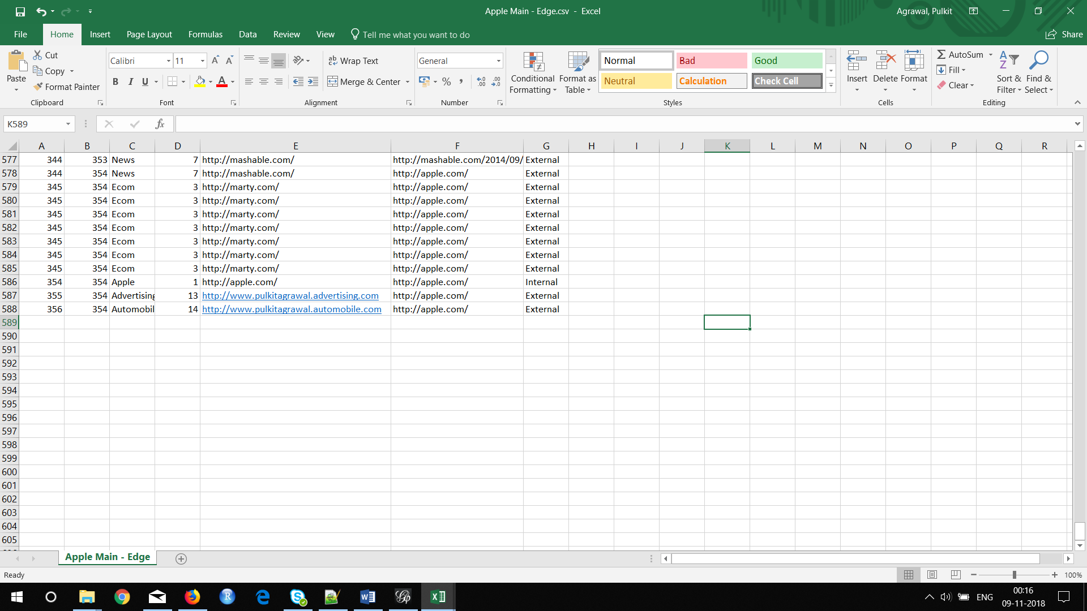

**Question:**

1. **Paste the screen shot of visualization in the overview tab.**

**Answer:**

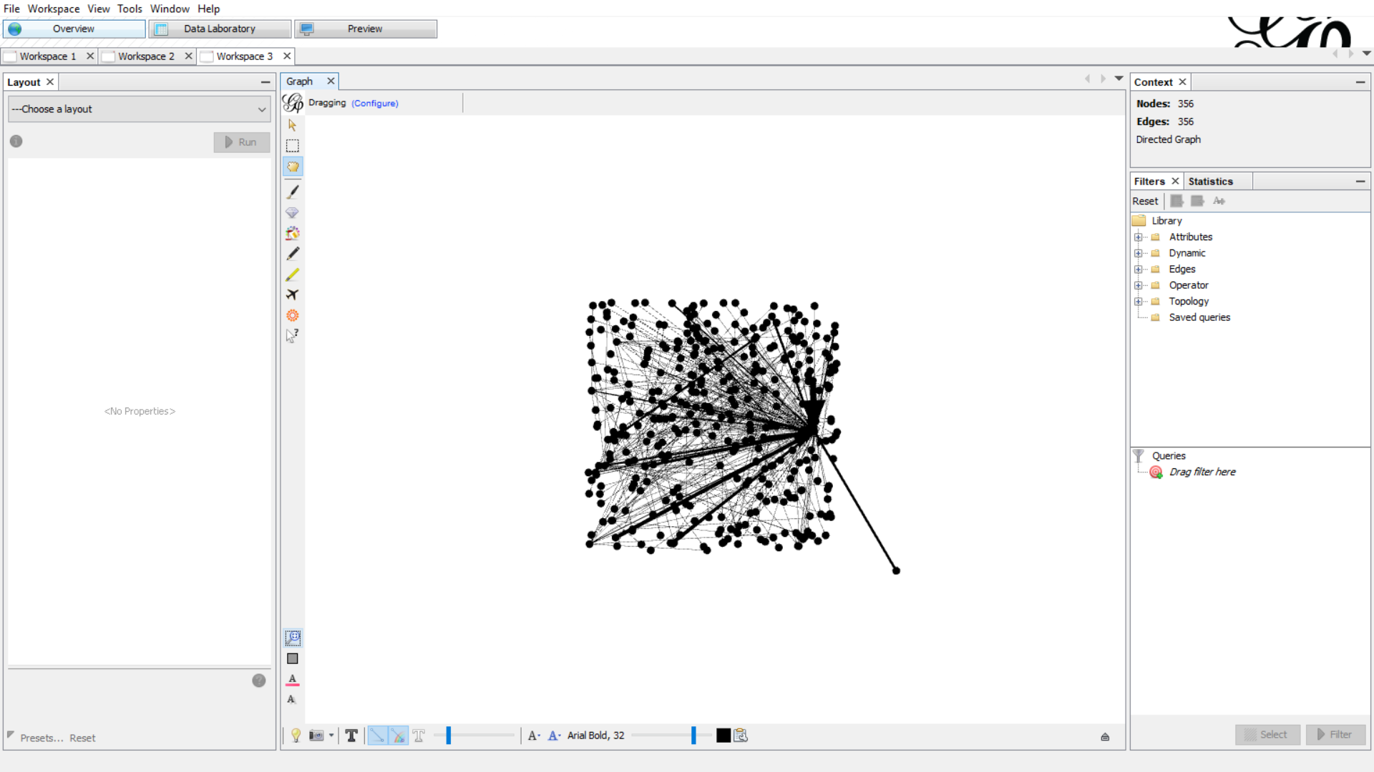

**Question:**

1. **Place the screen shot of your visualization section below.**

**Answer:**

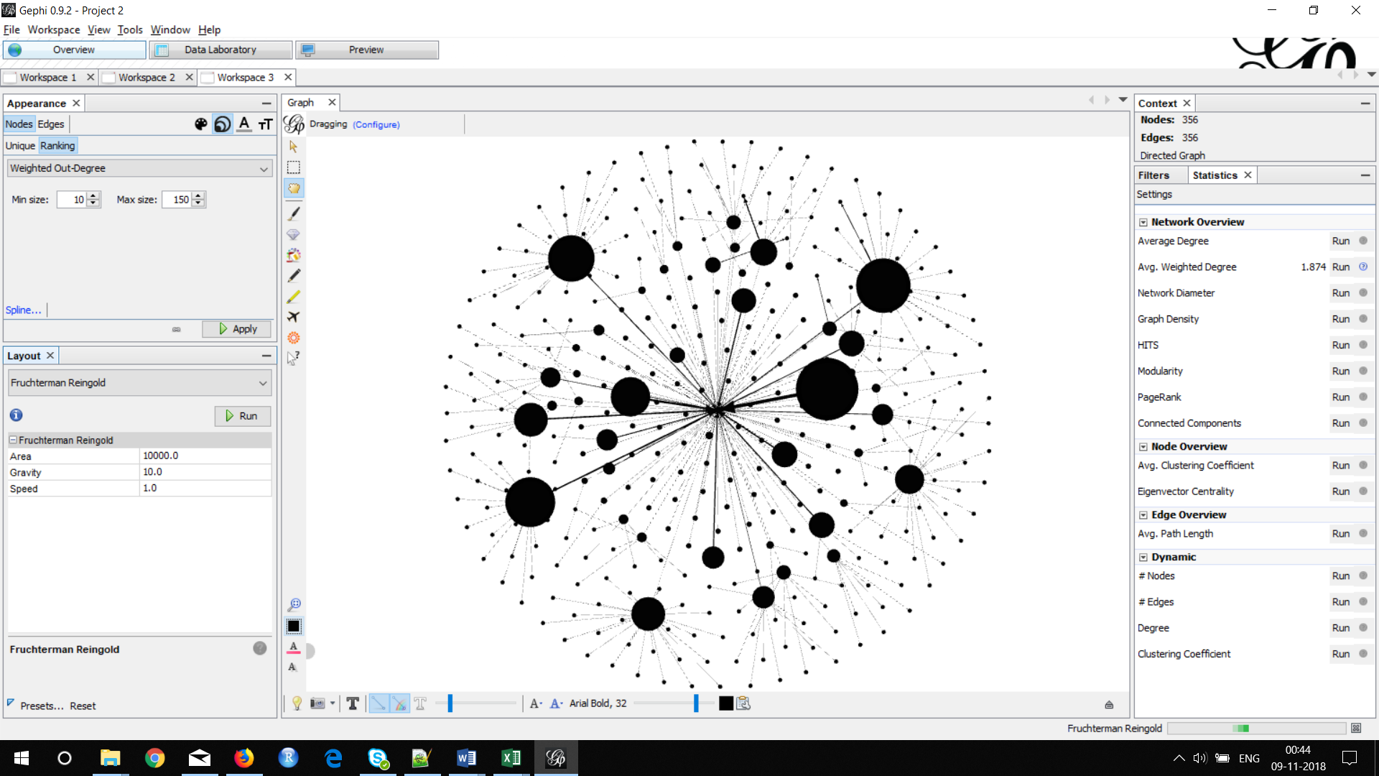

1. **Which website has got the maximum node size?**

**Answer:** The website http://www.PulkitAgrawal.advertising.com has got the maximum node size

**Question:**

1. **Paste the screen shot of your visualization/graph section.**

**Answer:**

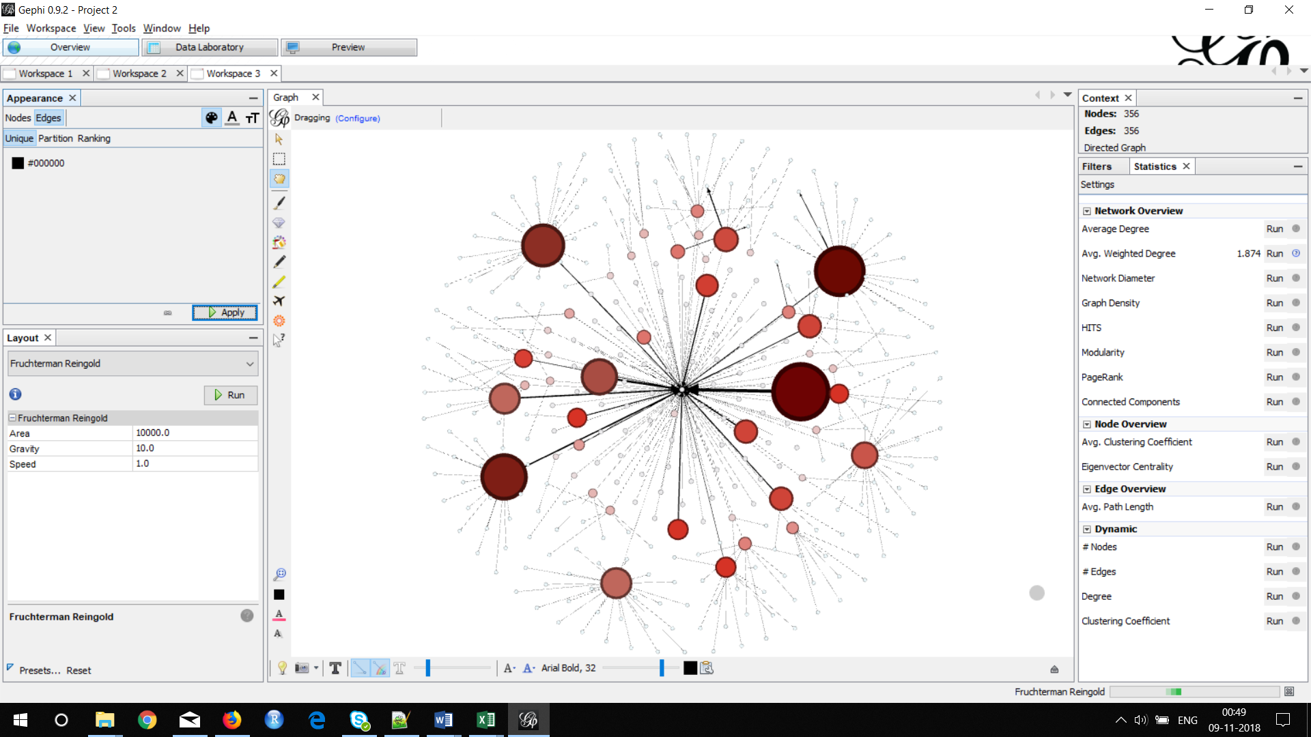

**Question:**

1. **Paste the screen shot of your Graph/Visualization section.**

**Answer:**

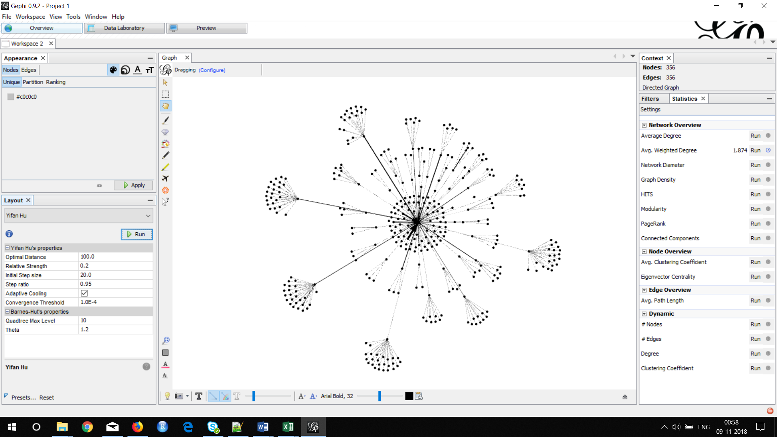

**Question:**

1. **Paste the screen shot of your Graph or Visualization Section.**

**Answer:**

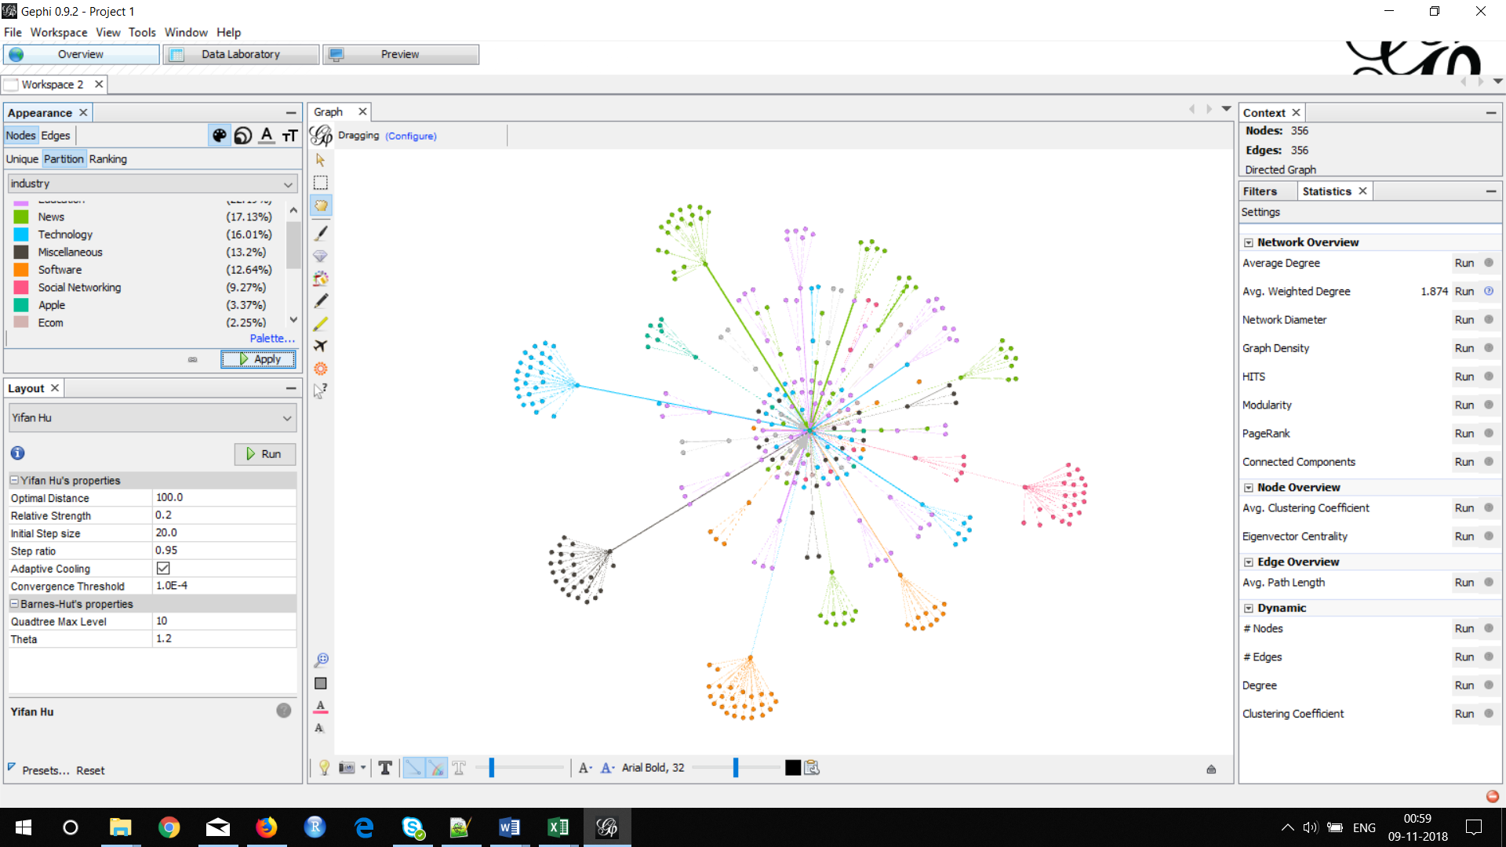

1. **Which website has got the strongest connection with Apple website? Also name its corresponding industry.**

**Answer: News** - <http://derstandard.at/>

**Education** - http://boston.cbslocal.com/

**Question:**

1. **Paste the screen shot of your Graph or Visualization section.**

**Answer:**

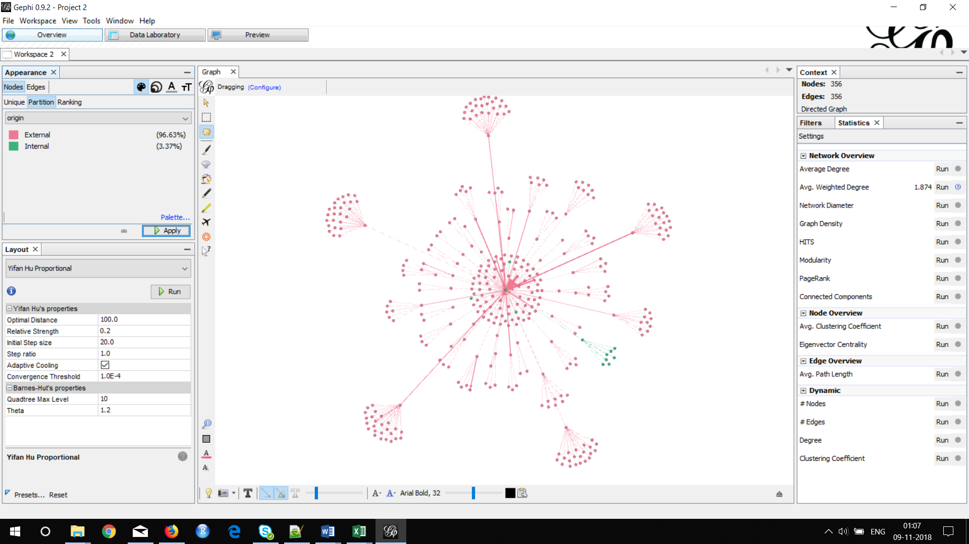

1. **How many internal nodes can you see from the graph excluding the central node?**

**Answer:** There is a total of 11 internal nodes excluding the central node

**Question:**

1. **Display each of the 3 exported .gexf files in the browser and paste the screen shot below.**

**Answer:**

1. **PulkitAgrawal_Website.gefx**

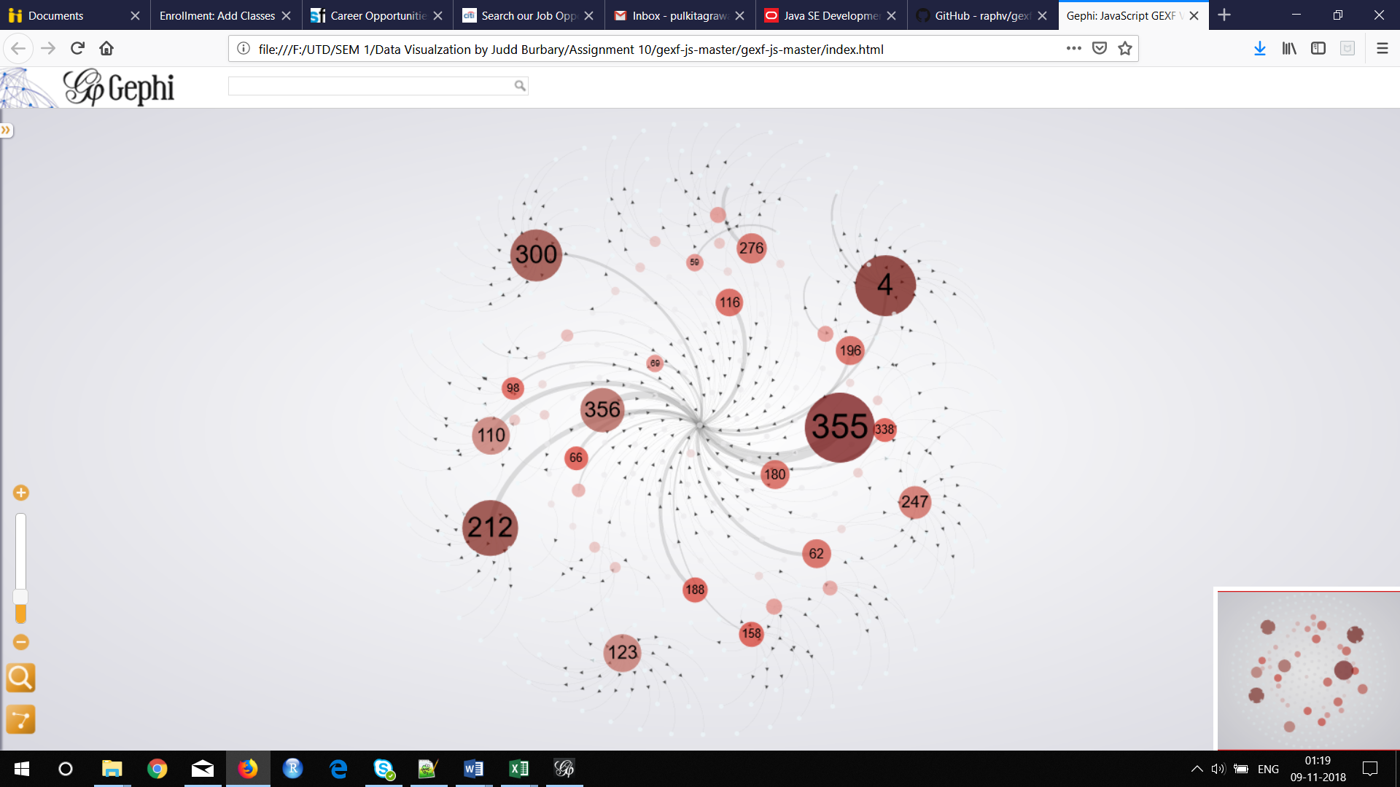

1. **PulkitAgrawal_Industry.gefx**

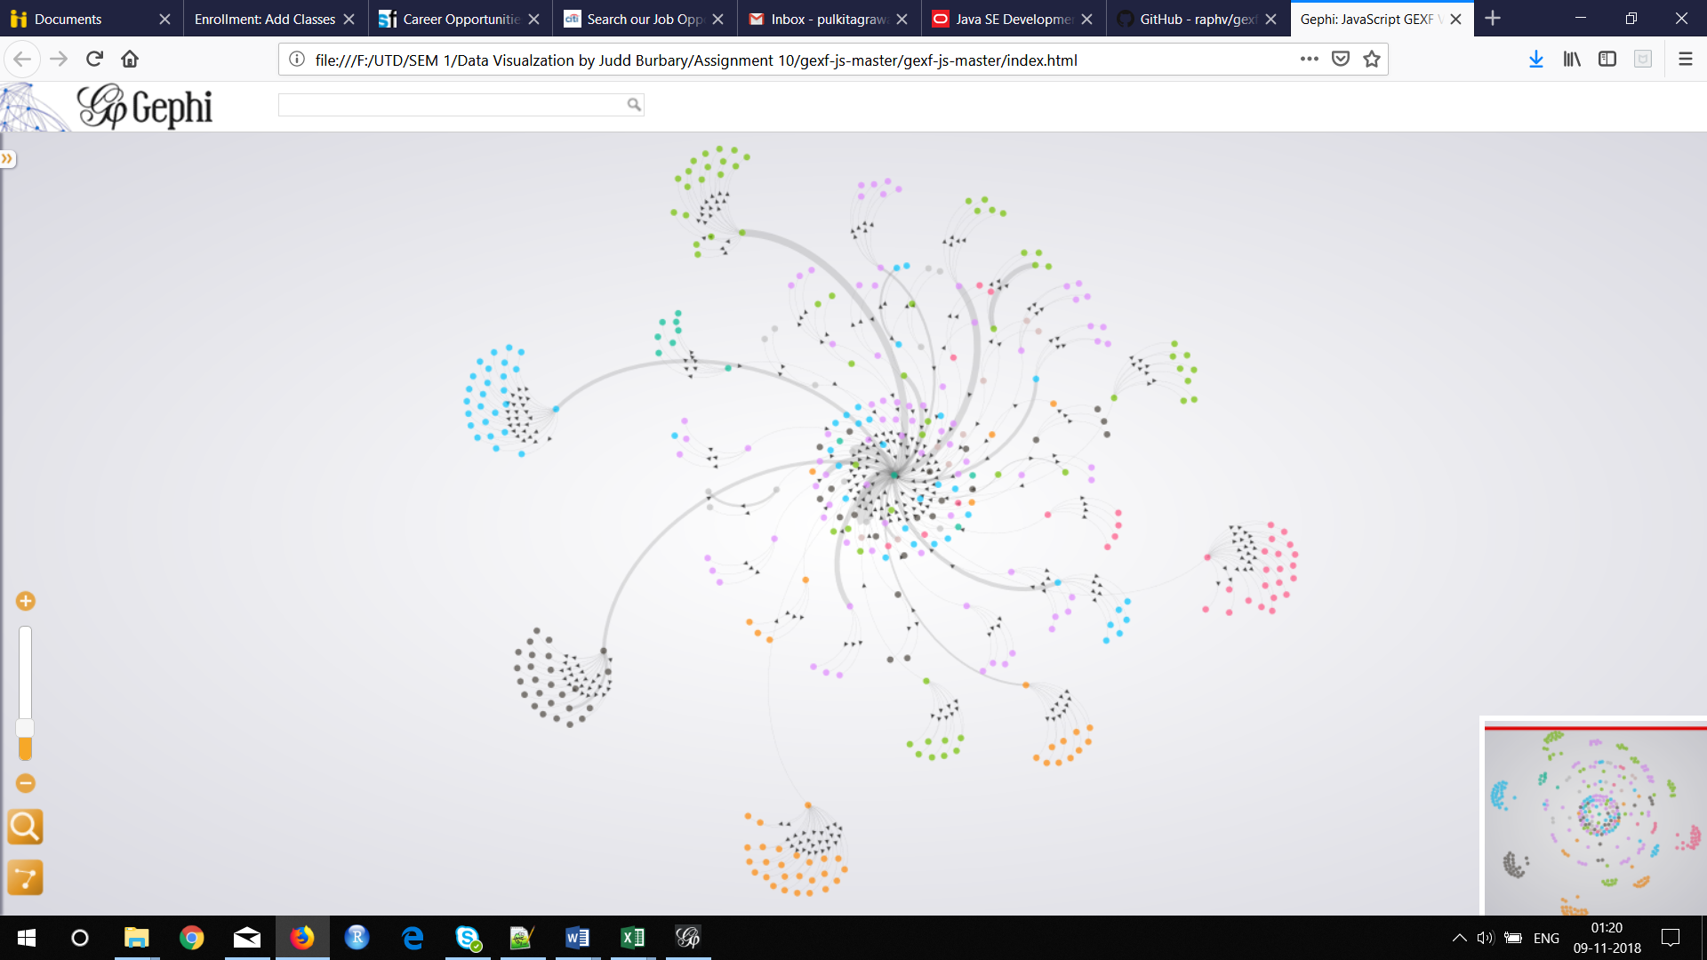

1. **PulkitAgrawal_IntExt.gefx**

